**DANANG SOFTWARE CORPORATION**

**SOFTECH-APTECH**



**Eproject:**

**BEAUTIFUL BEACH**

***Class: ADSE BATCH 171***

**Teacher: MSc QUOC DUNG LE**

**Students: QUOC HUNG NGUYEN (LEADER)**

**BAO TRAM NGUYEN THI**

**Name of group: GROUP 1**

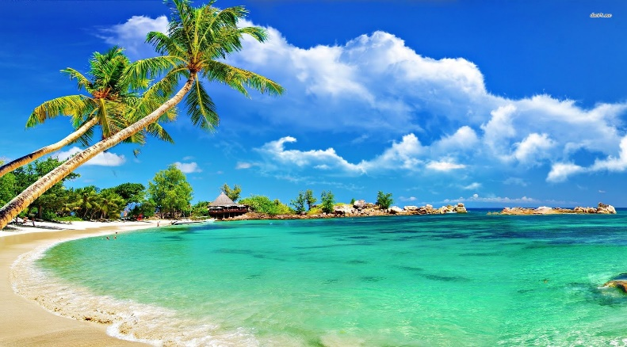

**TABLE OF CONTENTS**

1. **PROJECT PLANNING**
2. **ACKNOWLEDGE**
3. **INTRODUCTION**
4. **CUSTOMER REQUIREMENT**
5. Clients
6. Business Objective
7. Hardware Requirments
8. Software Requirments
9. Scope of the Work (in brief)
10. **SITE MAP**
11. **HOW TO USE THIS WEBSITE**
12. **Clients**
13. **Business Objective**
14. **CONCLUSION**

**APPENDIX**

**APPENDIX 1: WIRE FRAME**

**APPENDIX 2: COMPLETE WEBSITE**

# ACKNOWLEDGE

During the course of our project, we have had to ask the help of a number of people who are experienced and knowledgeable in the field of Website development. So with the completion of Web presentation made us happy. Without everyone's help, it would be difficult to complete because this is the first time that we have been able to do such a project. Therefore, we would like to thank those who have helped me:

First of all, we would like to thank our Instructor Mr. Quoc Dung for sharing his knowledge and experience and for guiding us to have the most complete project possible. This allows us to have a new and happier relationship with someone in the same profession and not only learn new knowledge, but we also learn a lot of things like teamwork, the joy of accomplishing something. created by me.

Next, I would like to thank Softech Aptech Center for creating an interesting working environment for students. And thank you for providing us with the necessary documents for this project. And finally I want to thank you for your support of a small part of the website details, so this project was completed at the right time.

This is the first time we do a project together so we can disagree and there may be errors in the Web site, so we hope that it will greatly affect the Web site. We hope that our project has been recognized and appreciated by the Center.

# PROJECT PLANNING

|  |  |  |  |  |
| --- | --- | --- | --- | --- |
| No. | Work | Member | Start – End | Status |
| 1 | Problem review | All team members | 27/06/22 - 01/07/22 | Completed |
| 2 | Image, video and data collecting | All team members | 02/07/22 - 17/07/22 | Completed |
| 3 | Design layout | Nguyen Quoc Hung | 17/07/22 - 01/08/22 | Completed |
| 4 | Home Page | Nguyen Quoc Hung | 17/07/22 - 01/08/22 | Completed |
| 5 | Navbar | Nguyen Quoc Hung | 17/07/22 - 01/08/22 | Completed |
| 6 | Footer | Nguyen Quoc Hung | 17/07/22 - 01/08/22 | Completed |
| 7 | Areas pages | Nguyen Thi Bao Tram | 17/07/22 - 01/08/22 | Completed |
| 8 | Top pages | Nguyen Quoc Hung | 17/07/22 - 01/08/22 | Completed |
| 9 | Contact page | Nguyen Thi Bao Tram | 17/07/22 - 01/08/22 | Completed |
| 10 | Gallery page | Nguyen Quoc Hung | 17/07/22 - 01/08/22 | Completed |
| 11 | Booking page | Nguyen Quoc Hung | 17/07/22 - 01/08/22 | Completed |
| 12 | Time and date | Nguyen Thi Bao Tram | 01/07/22 - 01/08/22 | Completed |
| 13 | Scroll to top button | Nguyen Quoc Hung | 17/07/22 - 01/08/22 | Completed |
| 14 | Customer count | Truong Minh Sang | 17/07/22 - 01/08/22 | Completed |
| 15 | Form validation | Nguyen Quoc Hung | 17/07/22 - 01/08/22 | Completed |
| 16 | Word files & download links | Nguyen Thi Bao Tram | 17/07/22 - 01/08/22 | Completed |
| 17 | Logo | Nguyen Thi Bao Tram | 17/07/22 - 01/08/22 | Completed |
| 18 | Remaining pages | All team members | 17/07/22 - 01/08/22 | Completed |
| 19 | PowerPoint | Nguyen Thi Bao Tram | 20/07/22 - 05/08/22 | Completed |
| 20 | Report | Nguyen Quoc Hung | 17/07/22 - 05/08/22 | Completed |
| 21 | Presentation | Nguyen Quoc Hung |  |  |

# INTRODUCTION

This project is "Beautiful Beach" - created for the purpose of introducing people to the most beautiful beaches in Vietnam, helping people to have more knowledge about cultures and great achievements in the field.

Currently, the demand for overseas travel is prevalent in most countries and learning about the tourist countries helps to understand the scenery and outstanding features of the country they intend to visit.

In addition, travel companies have a need to advertise the city and company's services to attract tourists. And this website also helps airlines to inform people about flight schedules, flights to cities that match the preferences of customers.

This website was created and developed using HTML5, CSS3, JavaScript, Geolocation (Google API), Bootstrap and other libraries. And works well on platforms including: Chrome, Microsoft Edge, FireFox, etc.

This Website is a collection of webpage, include:

* Home Page
* Area (include East, North, West, South)
* Top
* Contact
* Gallery
* Booking

# IV. CUSTOMER REQUIRMENT

3.1. Clients

“Beautiful Beach” is created for two types of clients:

* Site user to find out more knowledge about beaches including service, history, etc.
* People use the website to book flights and buses to travel to areas with beautiful beaches.

3.2. Business Objective

Functions of the website for businesses:

* Provide a place to advertise for travel agencies or for the country.
* Easily search and provide information about tourist destinations, flight times, schedules, tours for customers
* Know more news and events of Vietnam
* Become a partner of Beautiful Beaches and get appropriate benefits

3.3. Hardware Requirements

* Internet connection

3.4. Software Requirements

* Windows/Mac OS/Linux Destop/ Mobile Phone
* Web Browsers

3.5. Scope of the Work (in brief)

The following points indicate requirements based on which Amazing Beaches website needs to be developed:

1. **Page**:

* Home
* Area
* East
* North
* West
* South
* Top
* Contact
* Gallery
* Booking

1. **Home** should be created making use of Navbar with a suitable logo. In this page show a lot of pictures and information about some beautiful beaches, comments of famous people.

On each brief detail, the users can see quick view of the information and content. When the users move their cursor over into content, they can click "read more" to read all detailed information about it. This page also provides a search feature. The users can search for information, which they are interested in. After that, the users can be received the list of results, and they can click on the detailed link to discover information. Finally, Amazing Beaches logo, direct link, log in, signup, and link to the fan page of Facebook, Instagram and Pinterest are display in the footer

1. **Top** shows the list of areas and they will show the information about Top 4 famous beaches in this continent.
2. **Contact** will have a Address of the Company which should be displayed using GeoLocation API, the email address and phone number. Clients can give their opinions about Website and Developer can develop and repair Website.
3. **Gallery** will show the album of some wonderful beaches in Vietnam.
4. **Booking** is to assist customers in booking tickets to visit the beach
5. it displays items such as full name, date of birth, number of tickets, fare, ticket number that customer booked

# SITE MAP

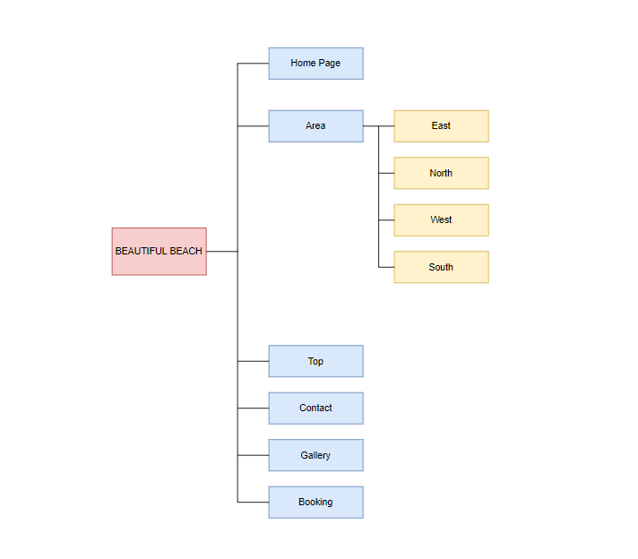

Figure 1. Site map diagram of Beautiful Beach.

# VI. HOW TO USE THIS WEBSITE

5.1. Clients

Clients can use it when they want to see photos abouts beaches in Vietnam of they can book the ticket.

* The user can visit the scenic spots and learn about the outstanding features and details of the beaches so that they can make a choice about how to travel. In addition, users can also read travelers' articles about food, reviews of people in this country and make their own choices when traveling.
* If you want to make a booking, please go to Booking to register your name, date of birth, phone number, card id. After registration is complete, you will show a list of flights for you to choose from. And so you have completed your booking with ease. You can pay through cash or bank card.

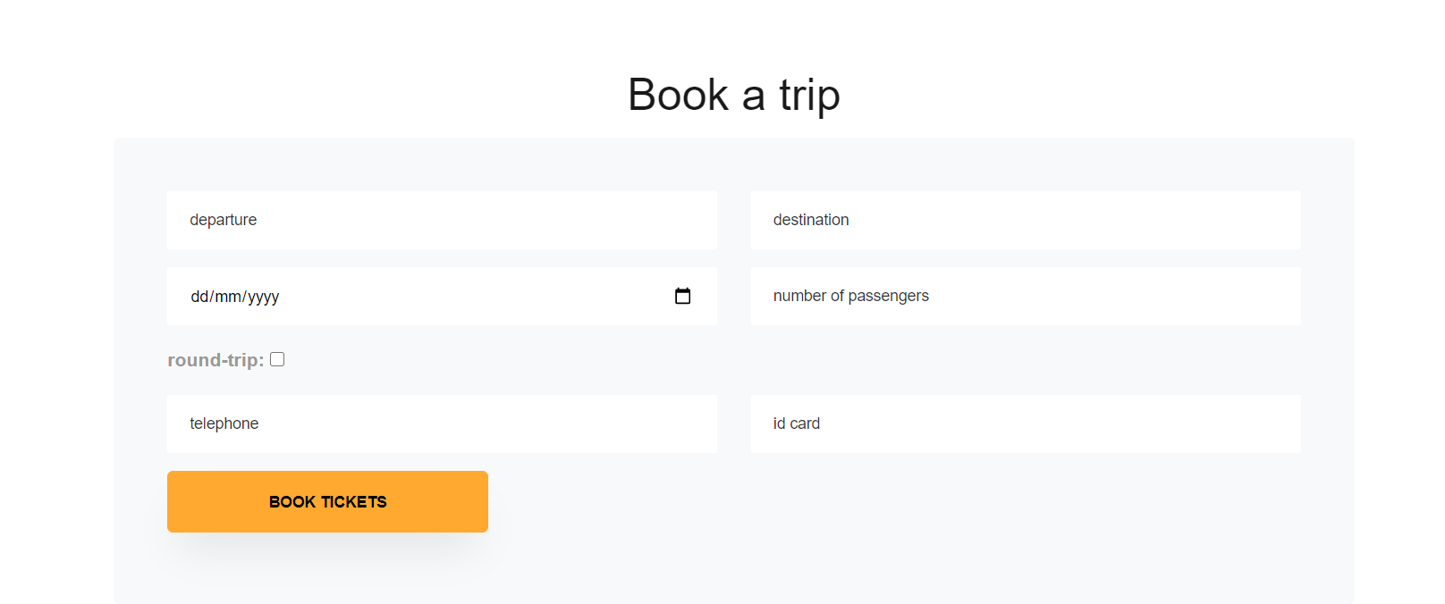

5.2 Bussiness Objective

* The partners can post advertisements on the website with a number of permissions to help users know more about promotions and services for visitors.
* Show users the flight schedule and recommend travelers to the right places to watch the beaches and relax while traveling

# CONCLUSION

**W**ebsite is created and developed to meet the needs of people traveling and consulting bridges around the world, focusing on front-end development technology. The website's user interface is designed in such a way that it helps customers to access various functions of Beautiful Beach as conveniently as possible. The team created a website that is suitable for your visitors so that everyone can easily access and interact with the web.

APPENDIX

APPENDIX 1: WIRE FRAME

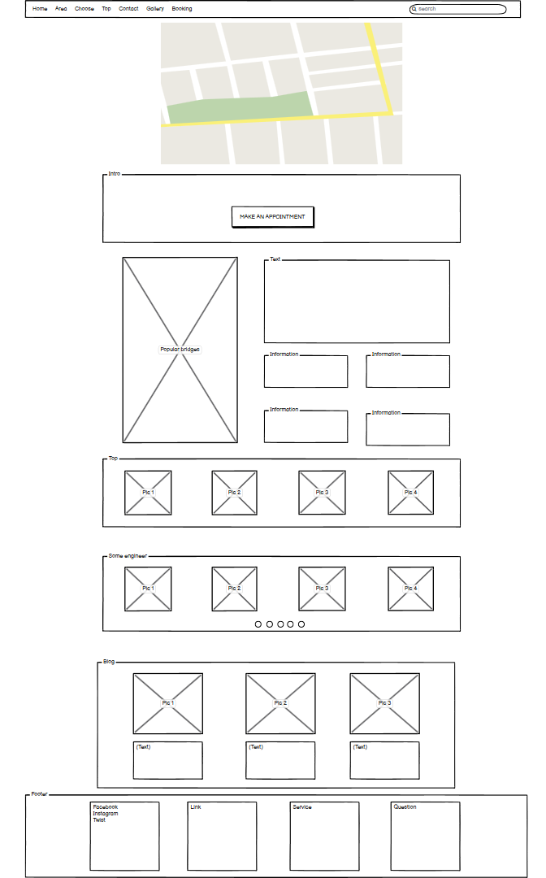

Home

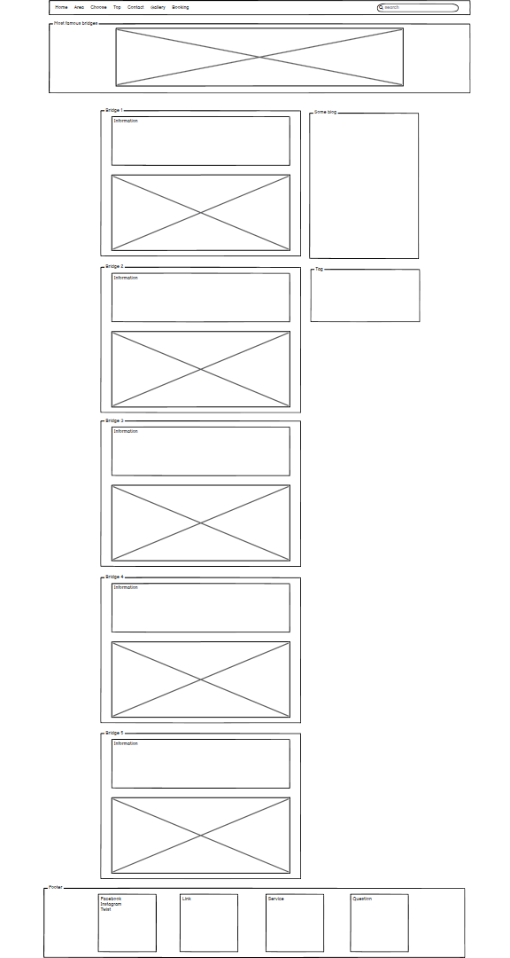

Top

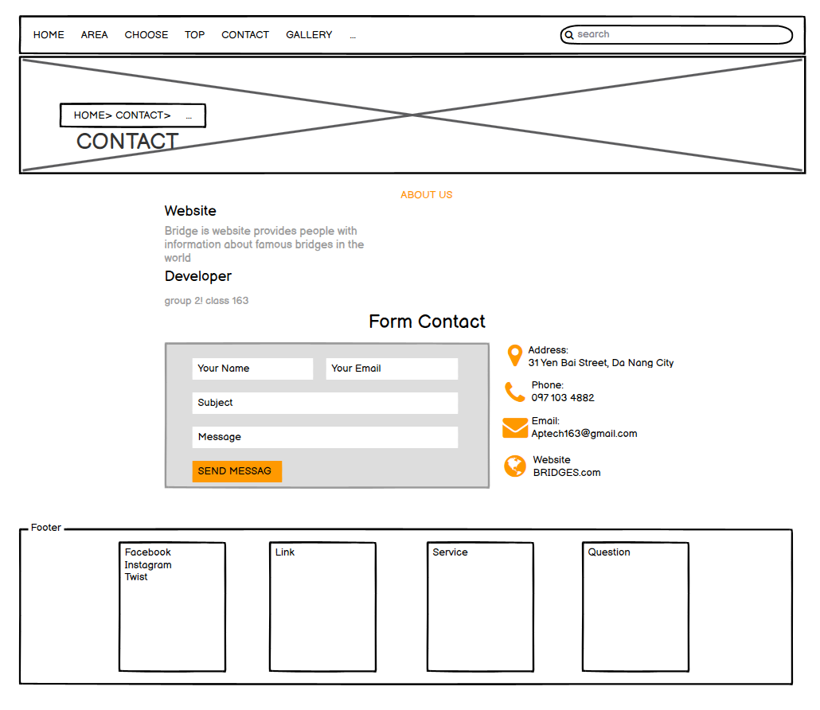

**Contact**

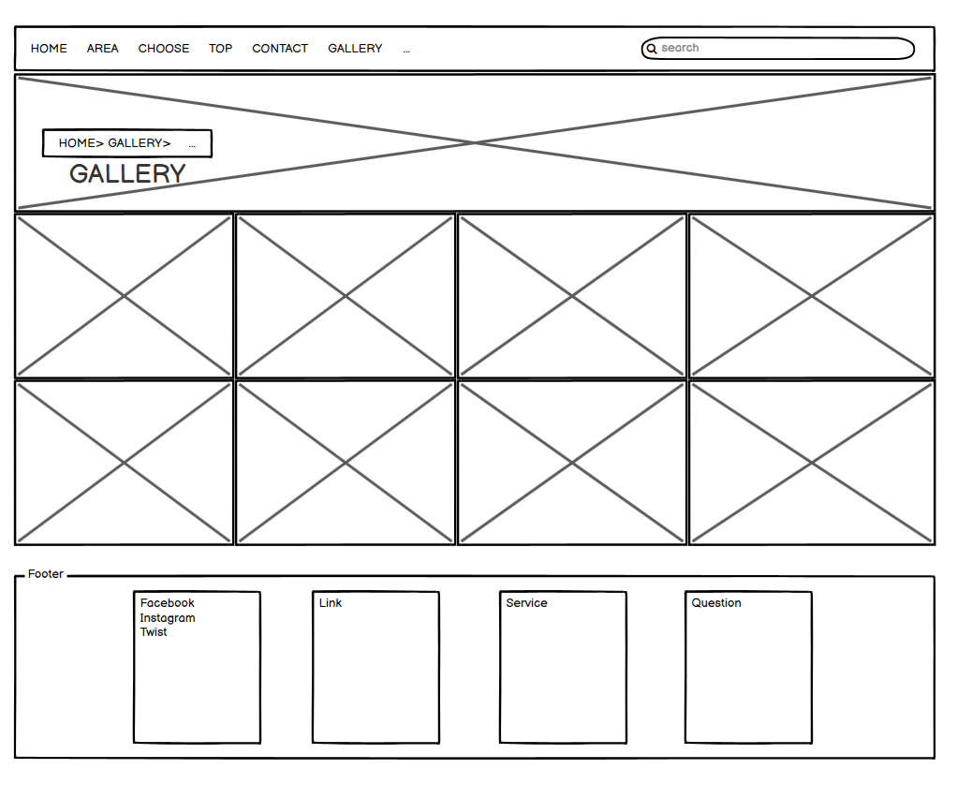

**Gallery**

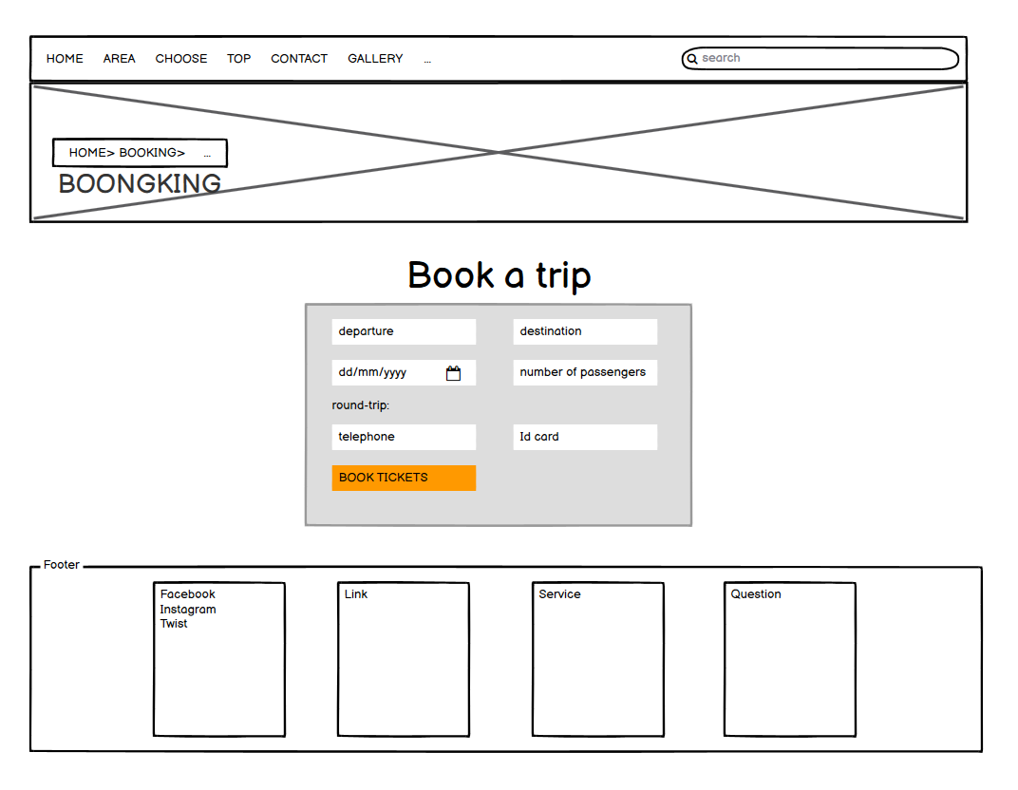

**Booking**

APPENDIX 2: COMPLETE WEBSITE

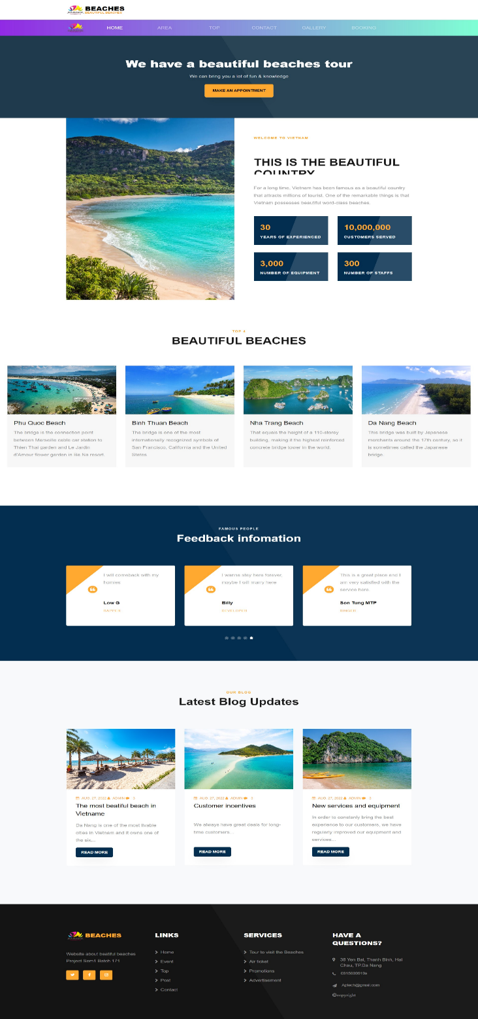

Home

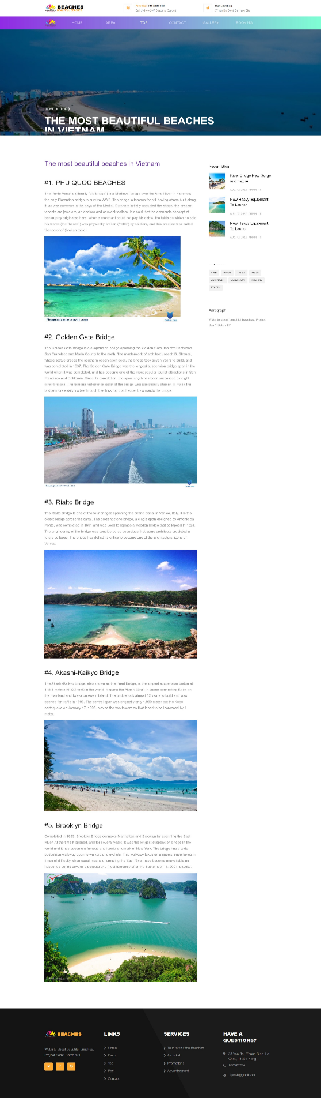

**Top**

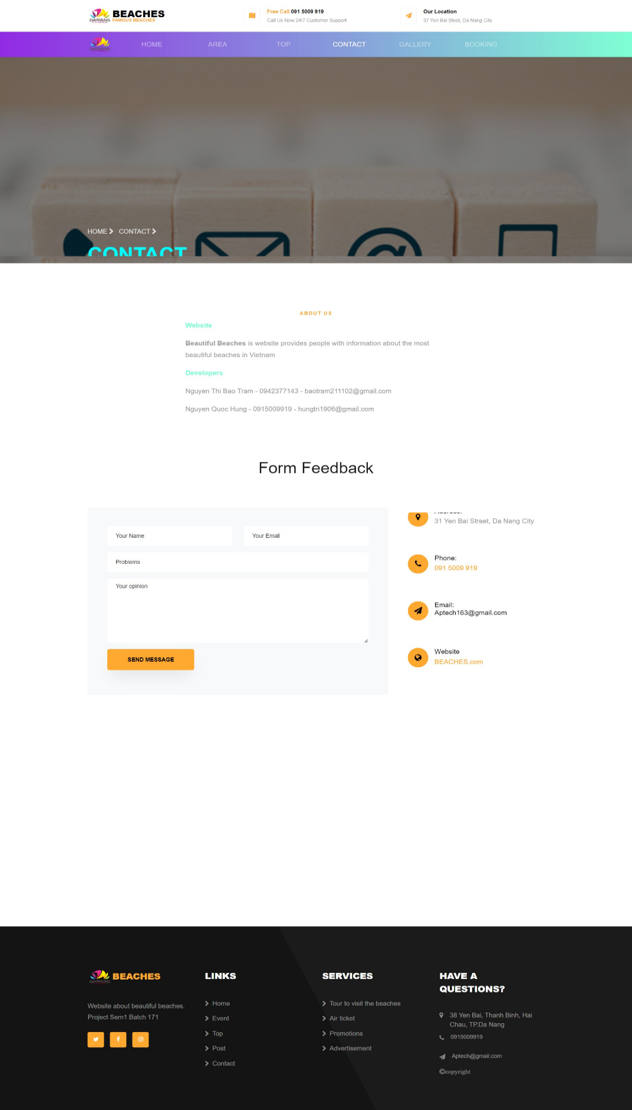

**Contact**

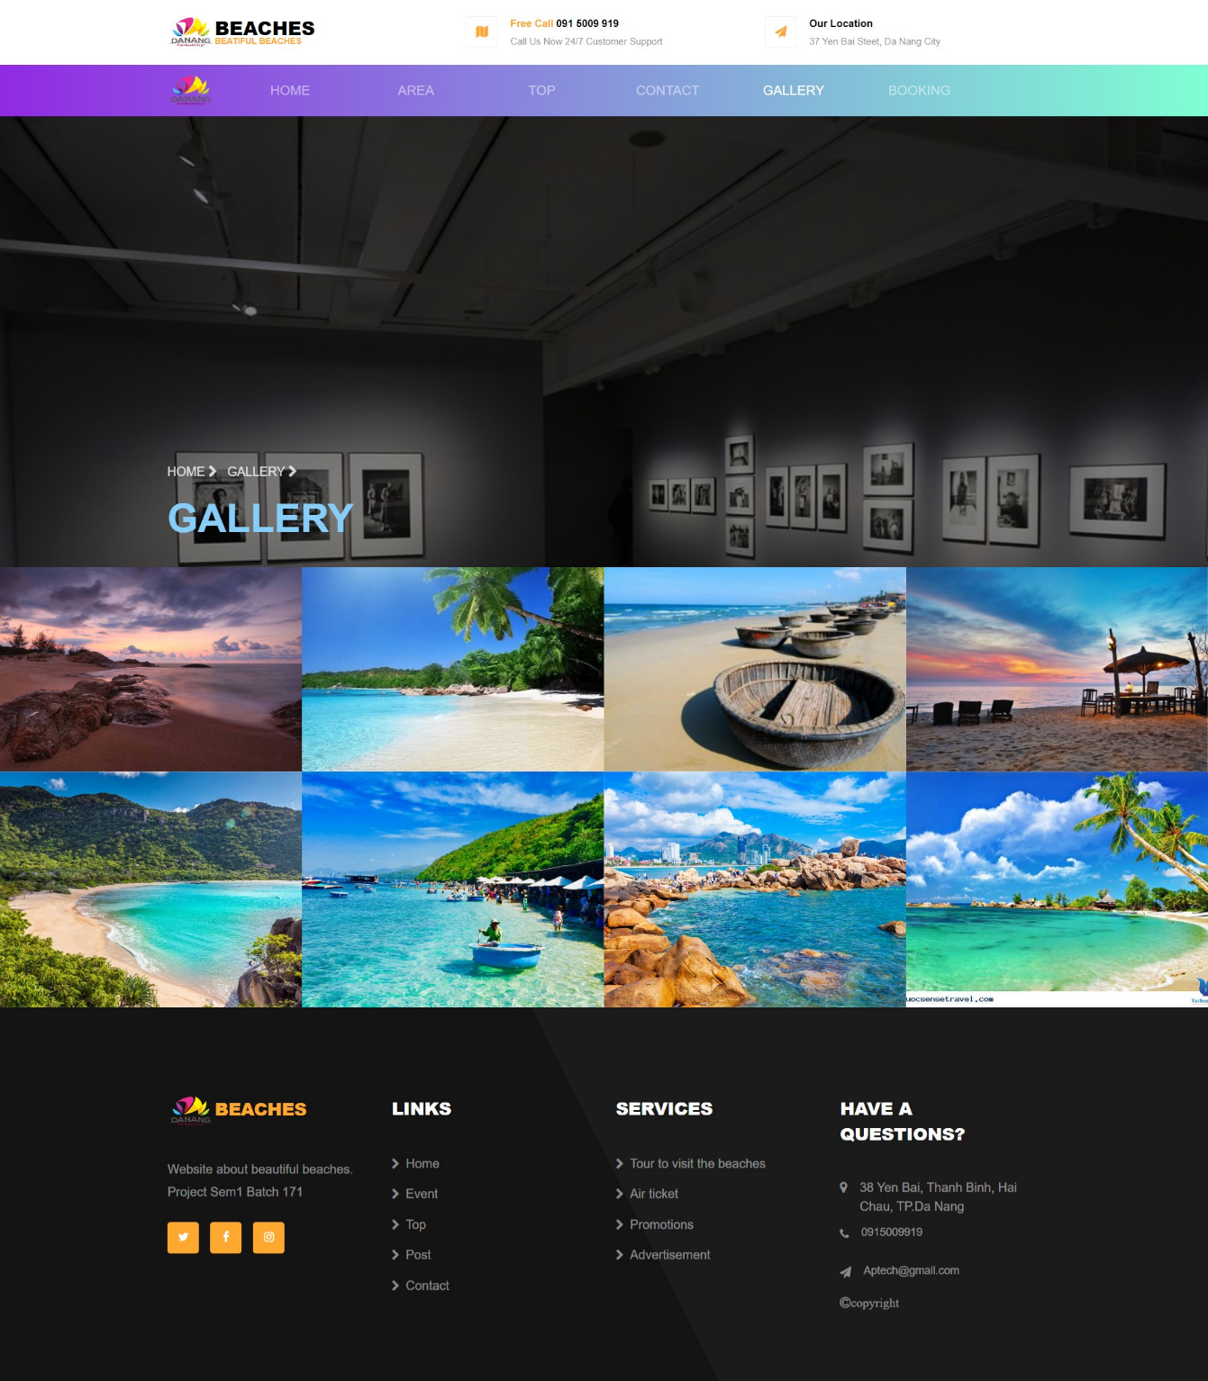

**Gallery**

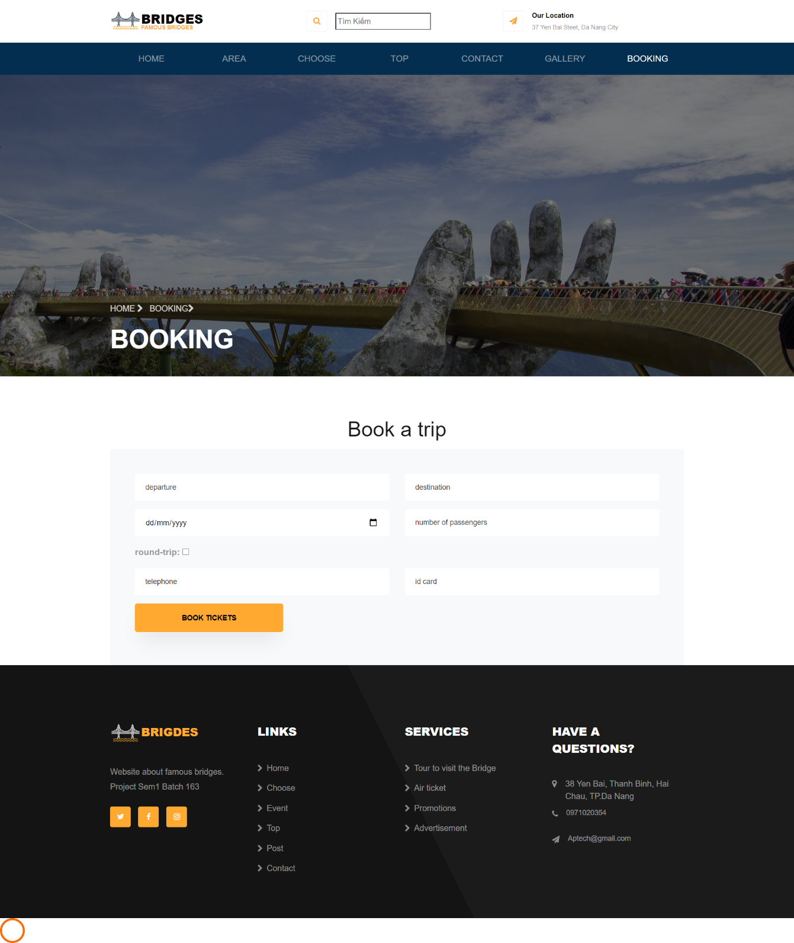

**BookingCONCLUTION**

**W**ebsite is created and developed to meet the needs of people traveling and consulting bridges around the world, focusing on front-end development technology. The website's user interface is designed in such a way that it helps customers to access various functions of Beautiful Beach as conveniently as possible. The team created a website that is suitable for your visitors so that everyone can easily access and interact with the web. In the future, the website will also have more features such as identification and incentives for familiar customers, allowing booking with accompanying entertainment services, ordering souvenirs ... to be able to serve customers optimally.

**References**

[1] <https://getbootstrap.com>

[2] <https://github.com>

[3] [Top 10 Most Amazing Beaches In The World - Abouticles](http://abouticles.com/amazing-beaches/?fbclid=IwAR0PuhNrkNrNHSG9jiC2Clt0HgpUvYuzIZy7vJGY1JdwYGt120krsTespWs)

[4] [World's 10 Most Amazing Beaches - MapQuest Travel](https://www.mapquest.com/travel/worlds-10-most-amazing-beaches/?fbclid=IwAR1i9Q7Ey8EABpWk3DrPn-GRZZ9ihyMAXeeQve5tjoZ5QEQbqQBS9MX20CE)